**Cloud Computing Lab Nayab khazin**

**BSE-V B**

**2023-BSE-046**

**LAB 10**

# Task 1 — GitHub CLI Codespace Setup & Authentication

* task1_gh_install.png

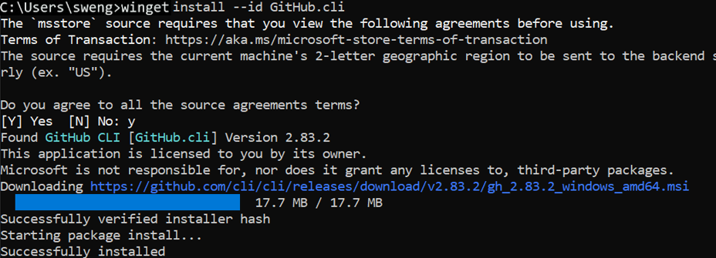

* task1_gh_auth_login.png

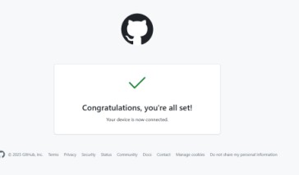 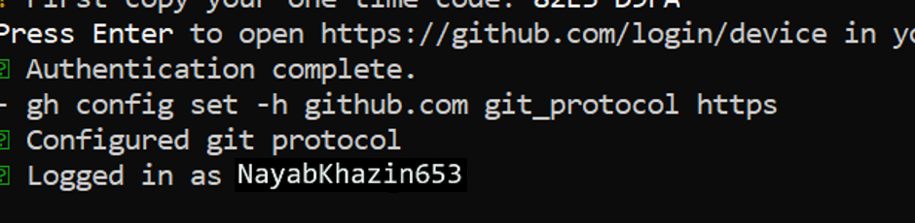

* task1_codespace_list.png



* task1_codespace_ssh_connected.png

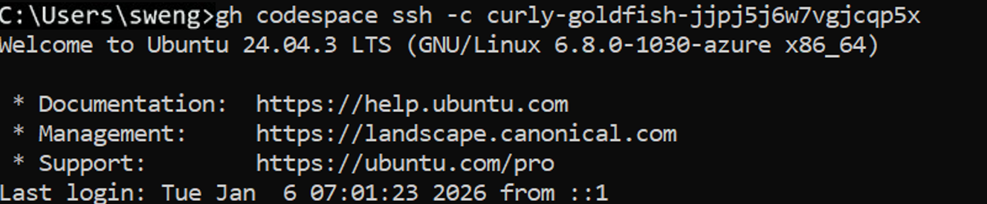

# Task 2 — Install AWS CLI, Terraform CLI, Provider Setup

* task2_aws_install_and_version.png



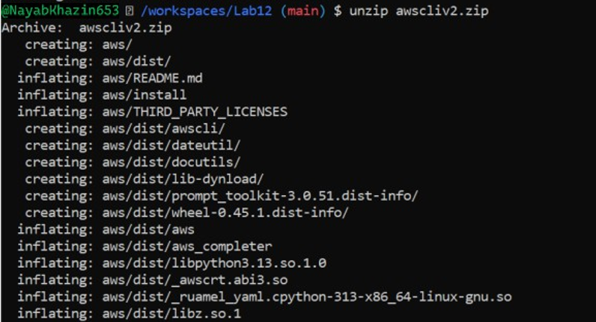 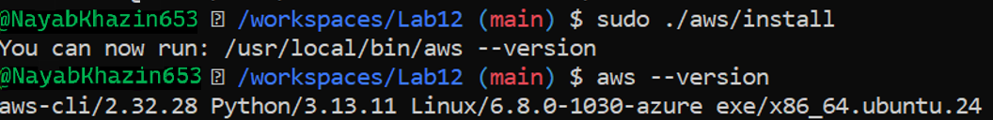

* task2_aws_configure_and_files.png

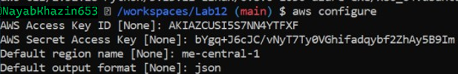 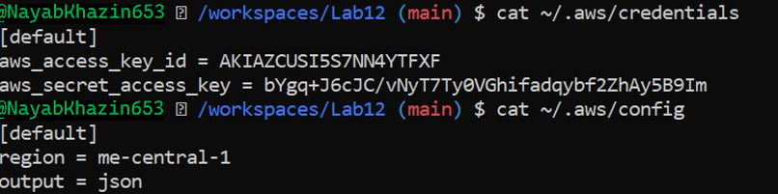

* task2_aws_get_caller_identity.png

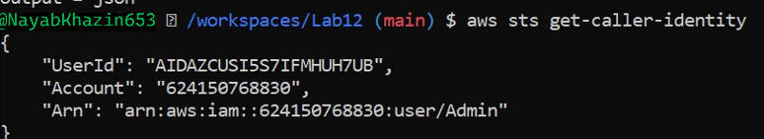

* task2_terraform_install_and_version.png

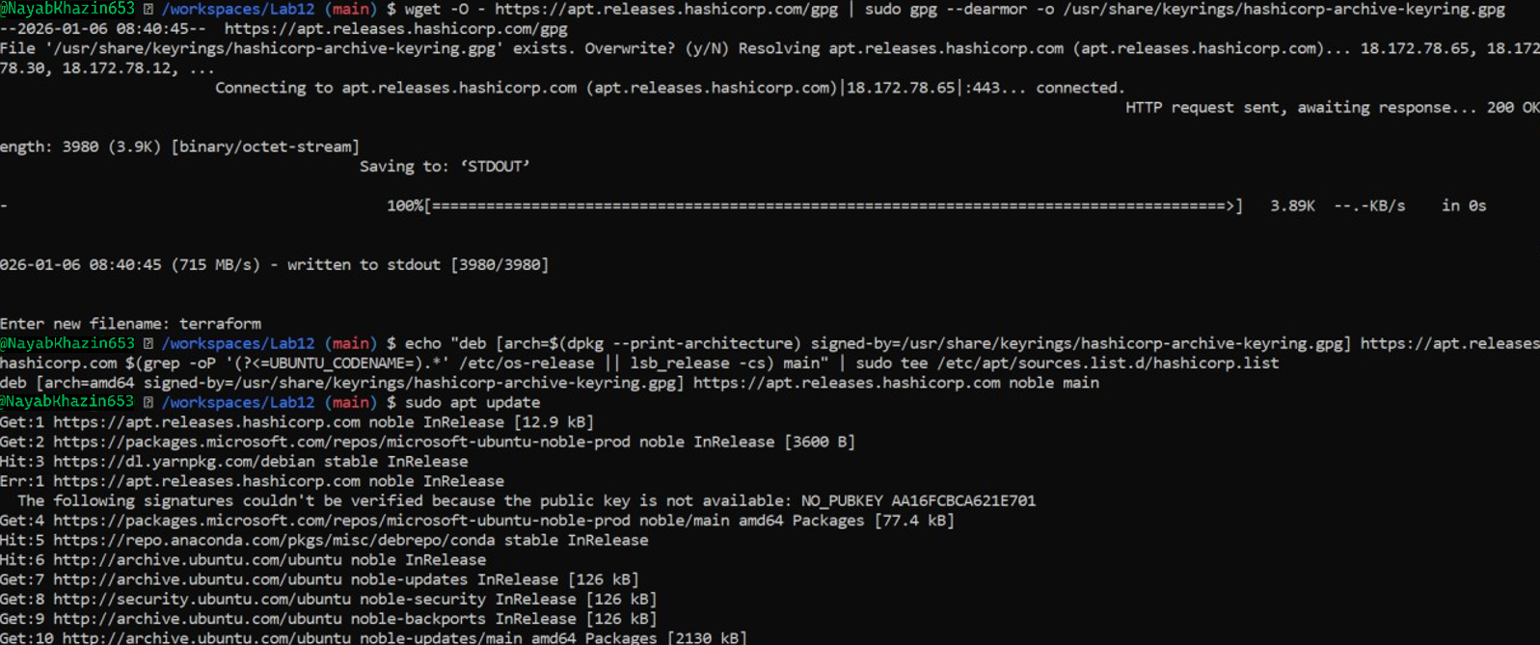

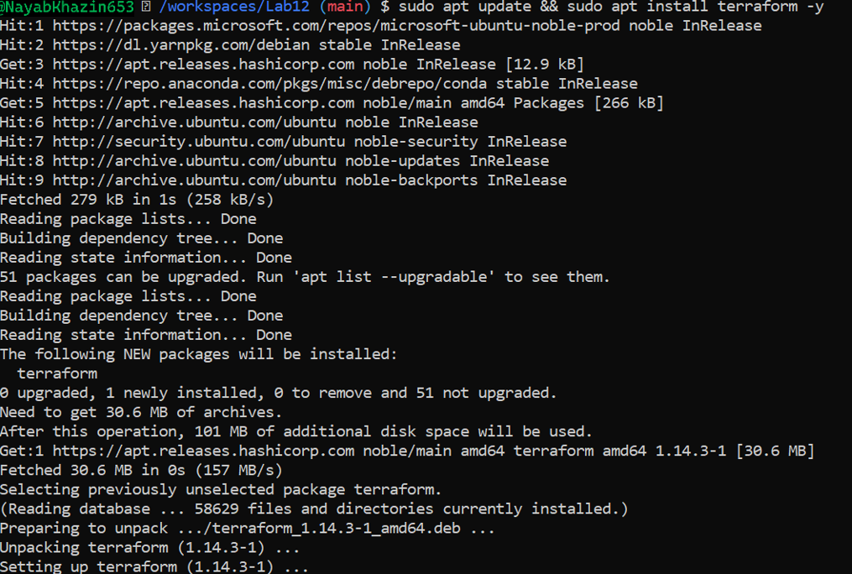

* task2_provider_file_creation.png

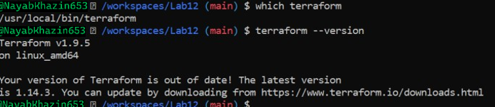

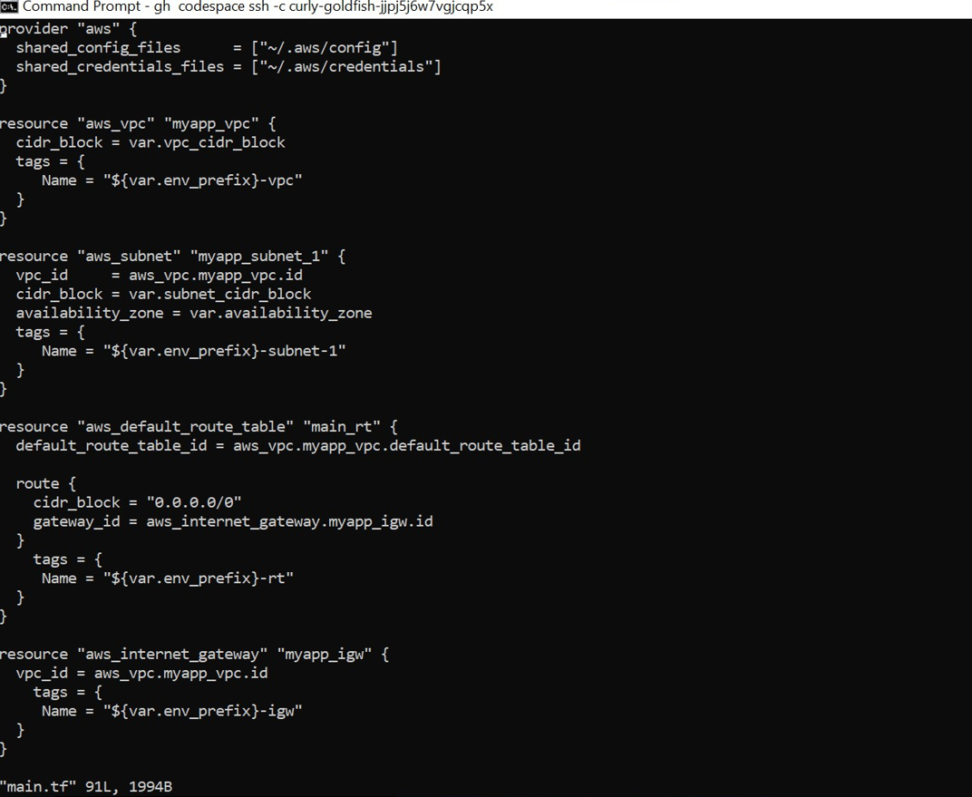

* task2_provider_block.png

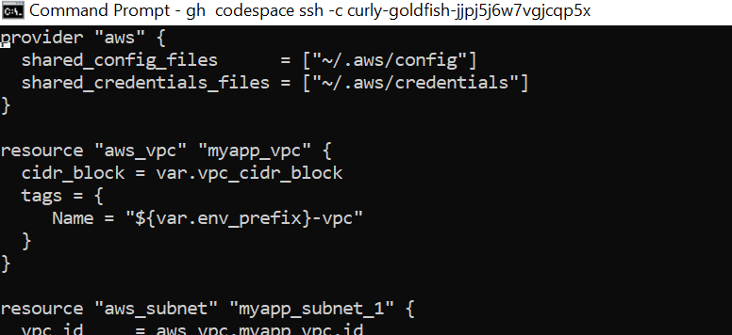

* task2_vim_save_main_tf.png

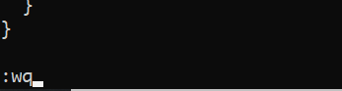 

* task2_terraform_init_output.png

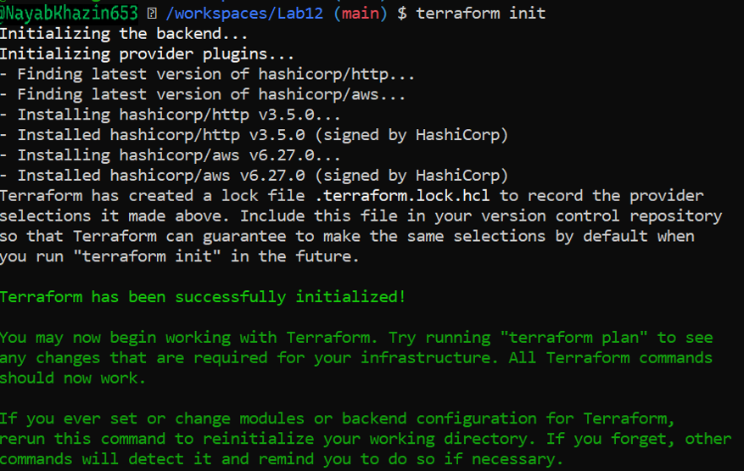

* task2_terraform_lock_hcl.png

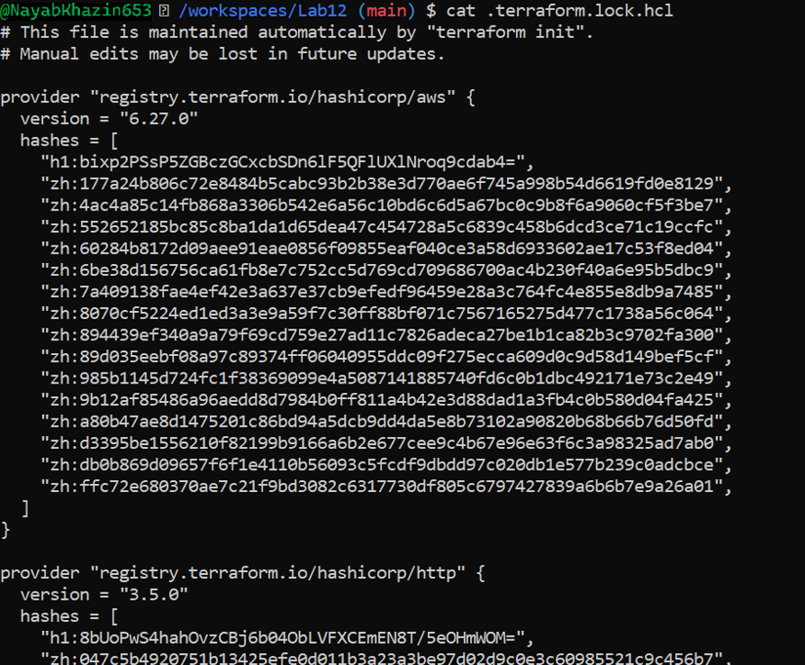

* task2_terraform_dir_ls.png

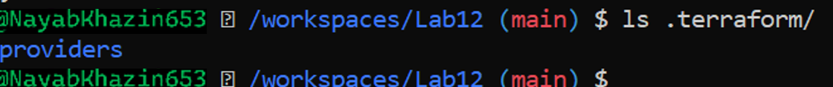

# Task 3 — VPC/Subnet Creation, Initialization, Verification

* task3_main_tf_resource_add.png

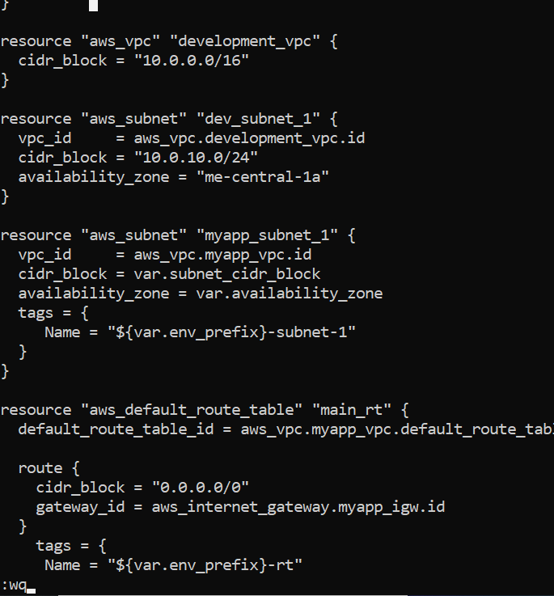

* task3_terraform_apply_vpc_subnet.png

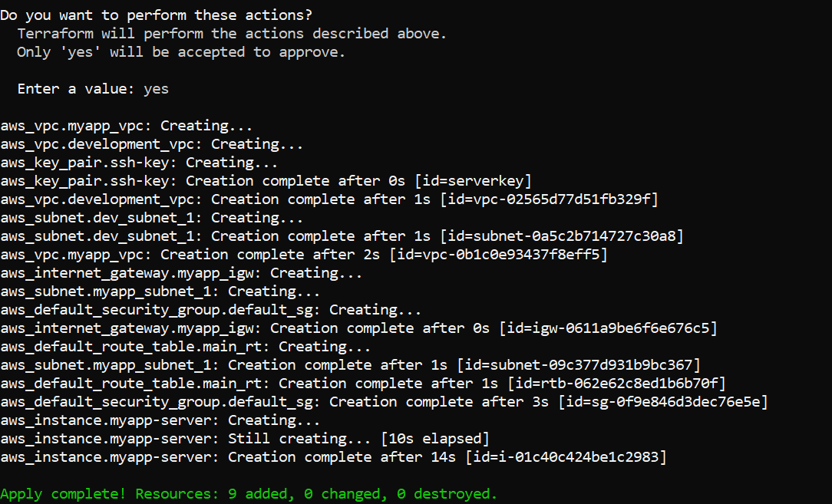

* task3_aws_cli_verify_subnet.png



* task3_aws_cli_verify_vpc.png



# Task 4 — Data Source, Targeted Destroy, Tags

* task4_main_tf_datasource_resource_add.png

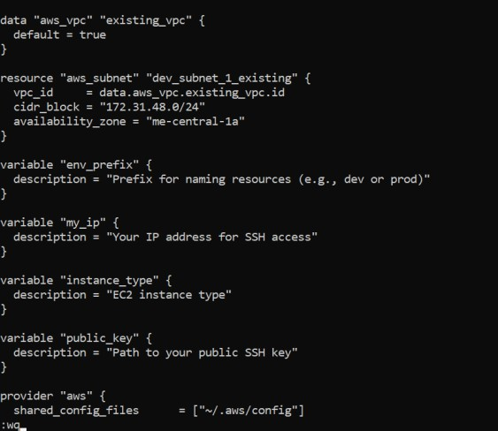

* task4_terraform_apply_datasource_resource.png

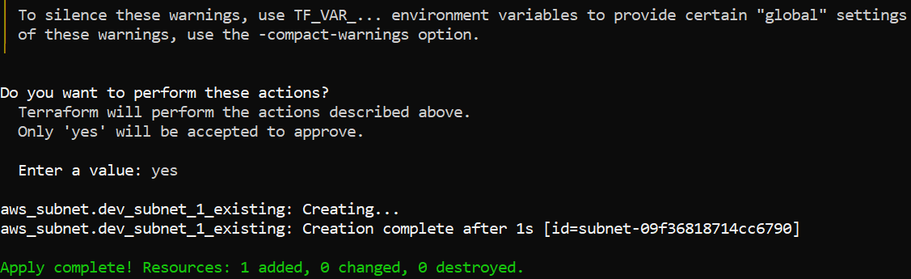

* task4_terraform_destroy_targeted.png

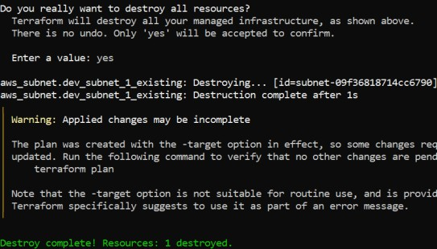

* task4_terraform_refresh_state.png

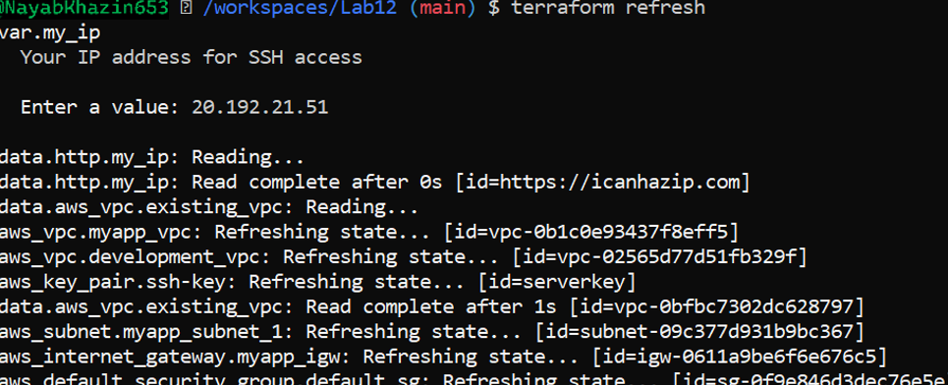

* task4_terraform_apply_after_refresh.png

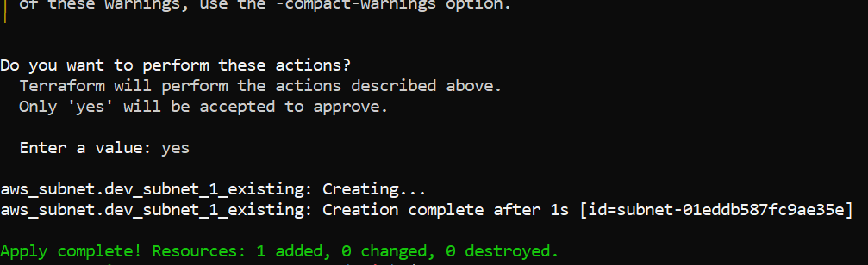

* task4_terraform_destroy_all.png

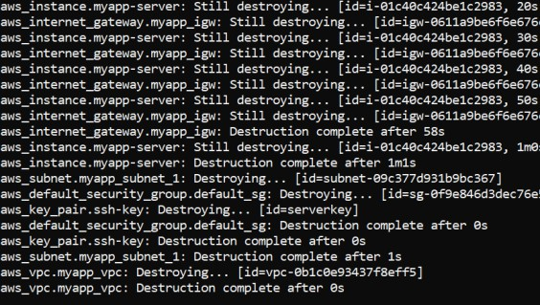

* task4_terraform_plan_output.png

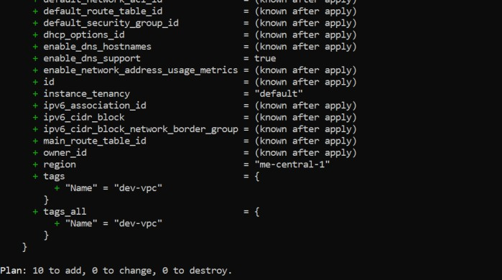

* task4_terraform_apply_after_destroy.png

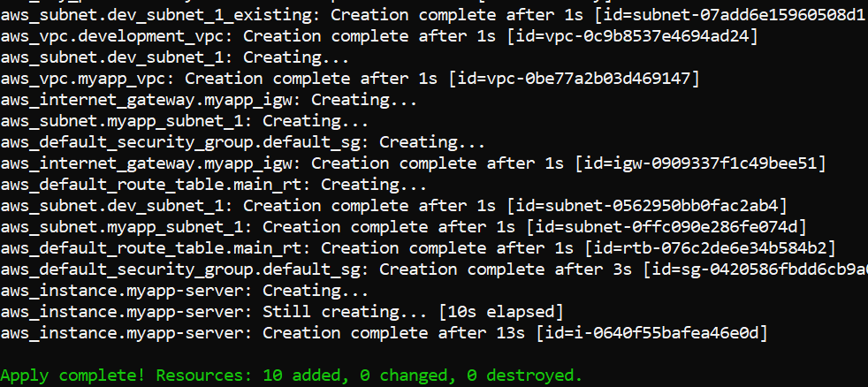

* task4_main_tf_tagging.png

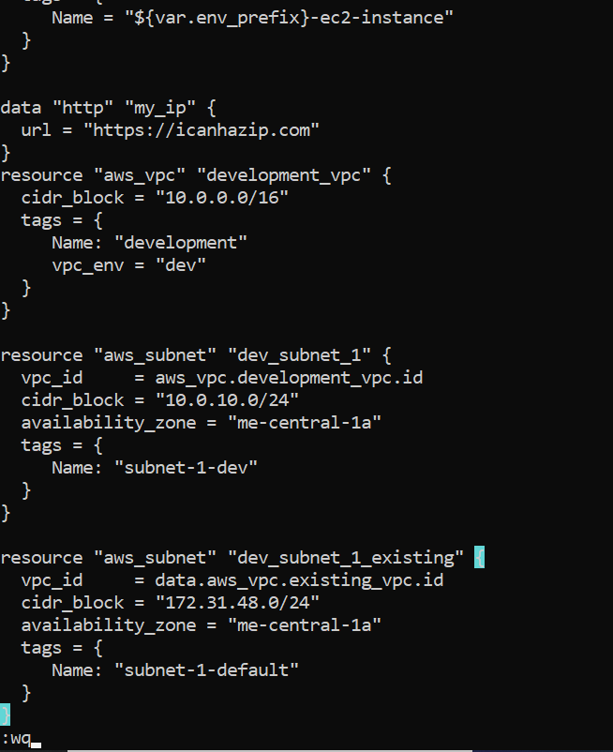

* task4_terraform_apply_tagging.png

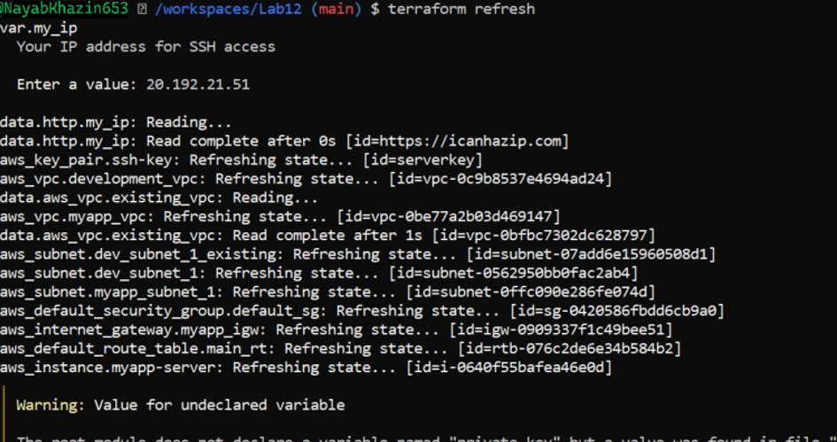

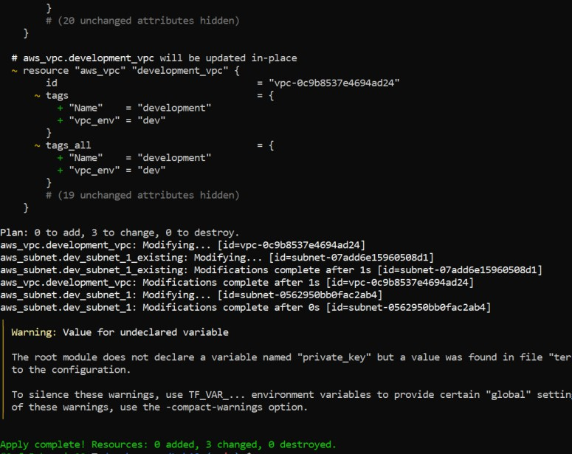

* task4_terraform_plan_remove_tag.png

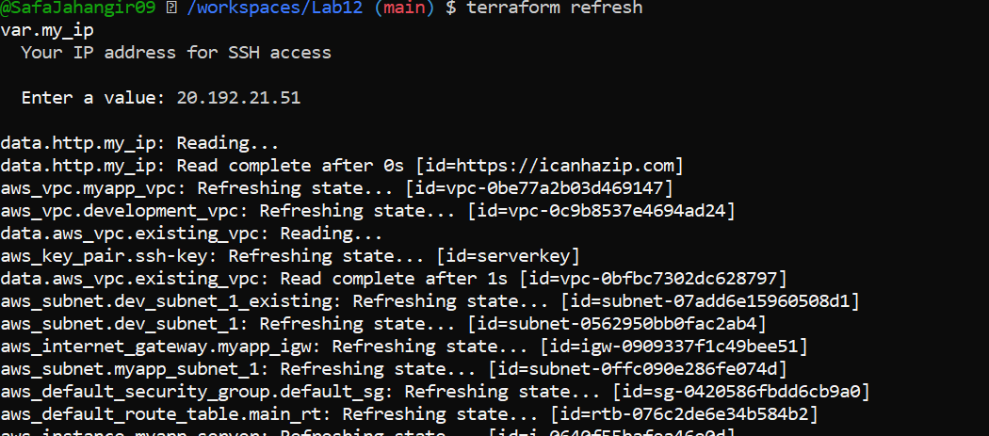

* task4_terraform_apply_remove_tag.png

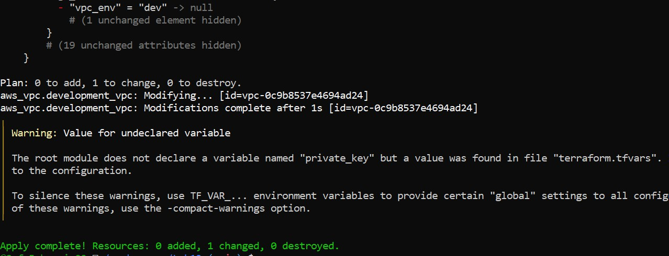

# Task 5 — State File Inspection & Terraform State Commands

* task5_terraform_destroy.png

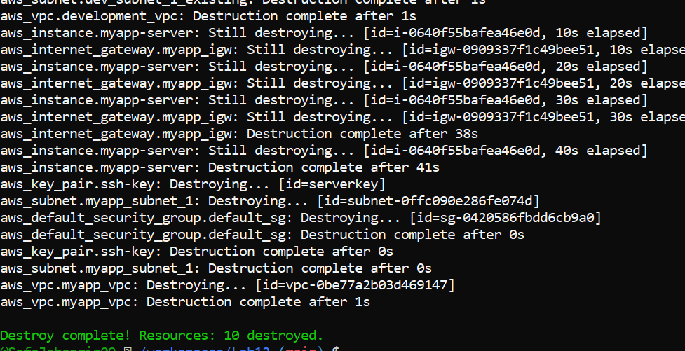

* task5_terraform_state_file_empty.png

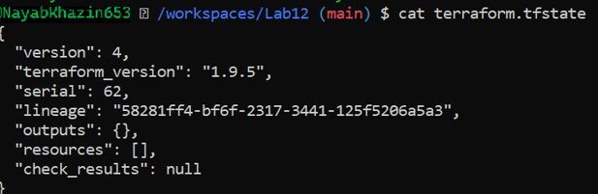

* task5_terraform_state_backup_prev.png

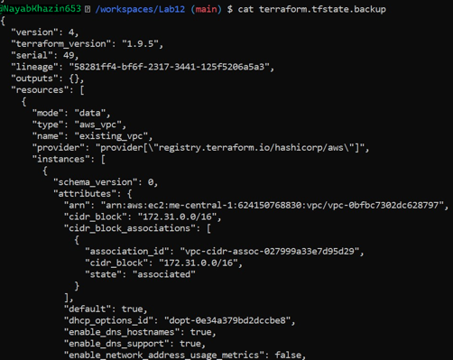

* task5_terraform_apply_recreated.png

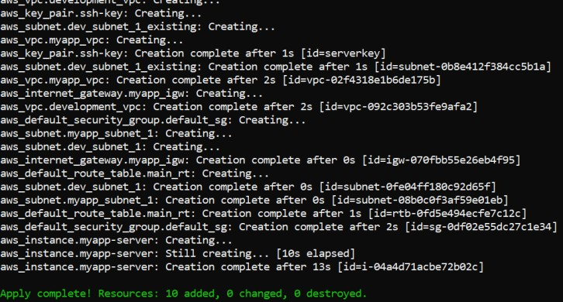

* task5_terraform_state_file_populated.png

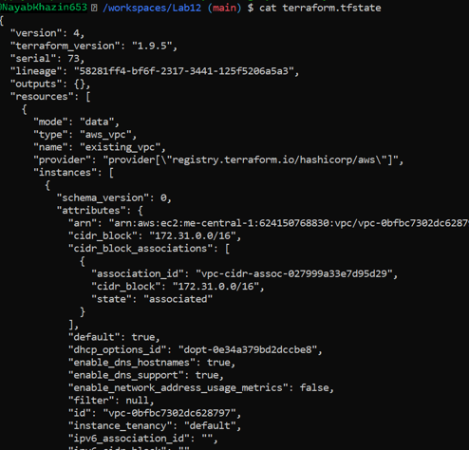

* task5_terraform_state_backup_empty.png

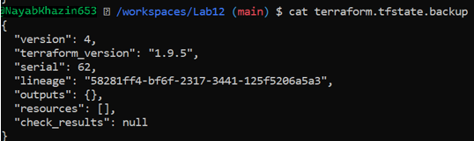

* task5_terraform_state_list.png

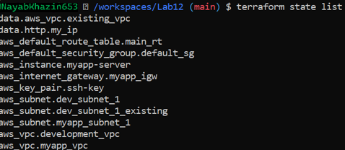

* task5_terraform_state_show_resource.png

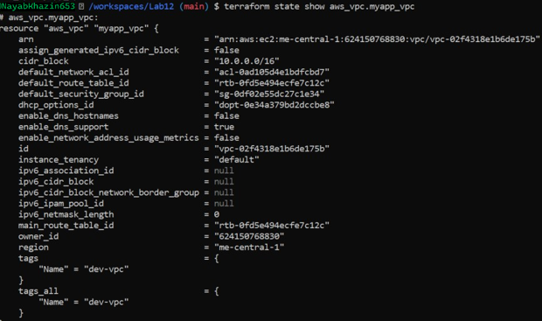

# Task 6 — Terraform Outputs & Attributes Reporting

* task6_terraform_outputs_basic.png

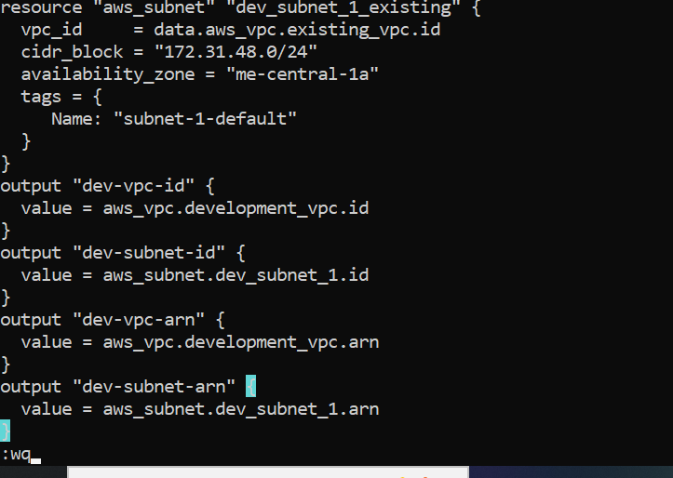

* task6_expanded_outputs.png

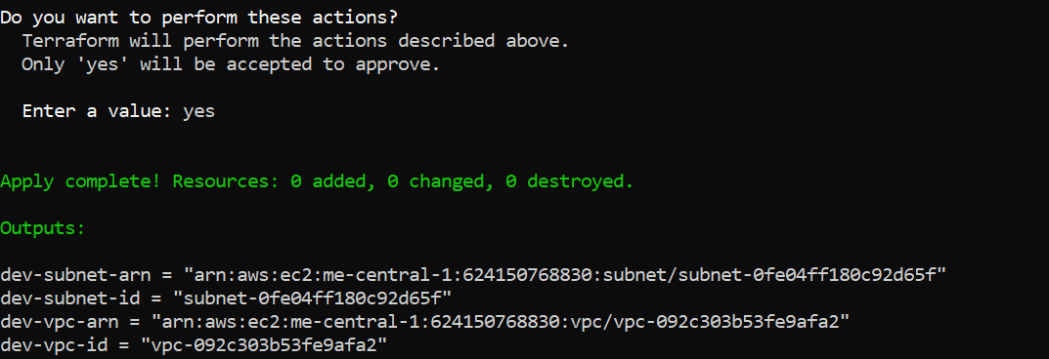

# Cleanup — Delete Resources & State Verification

* cleanup_destroy_resources.png

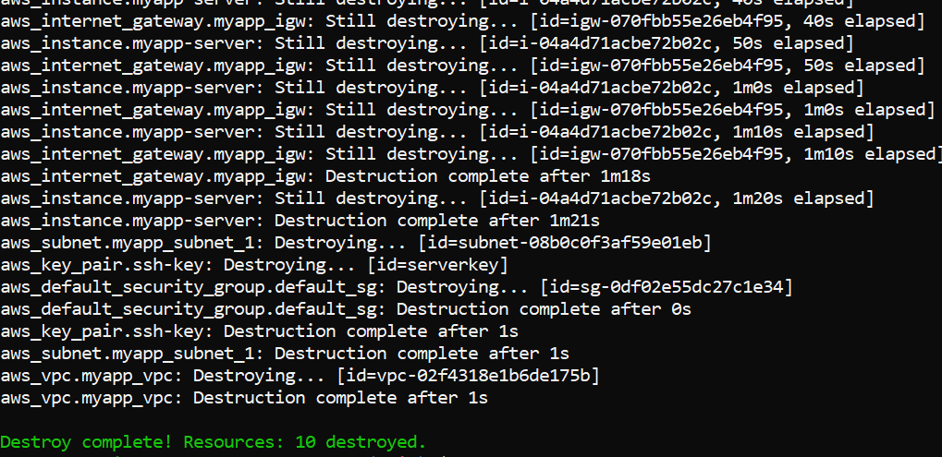

* cleanup_state_files.png

